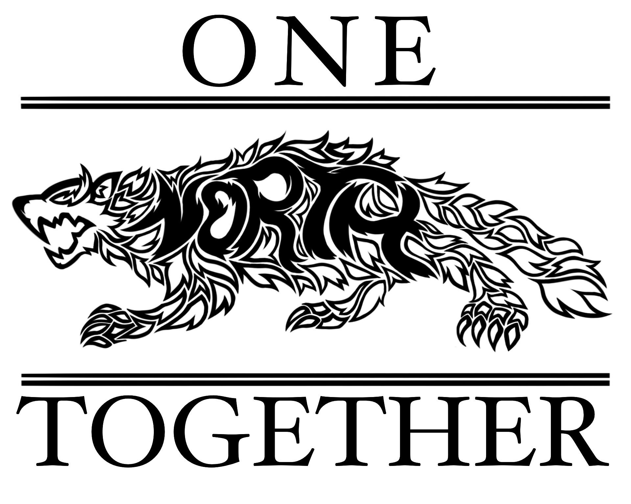

NSHS PTSO Board Meeting
July 5, 2023

Attendees: Dr. Turner, Stacey Bertotti, Dionne Wiggins, Jen Patton and Marney Lumpkin

I. Call to order – 5:05pm

II. Approve minutes from May 10, 2023 – all approved

III. Treasurer Report
- Fiscal year-end report
  - $23,843.01 as of COB 6/30/23
  - Ended better than what we started with
  - Tighten up our coming year budget
  - Goal to keep $15K in the account at all times
  - Dionne Wiggins and Marney Lumpkin will audit last year’s books
  - Jen Patton will file taxes
- Prepare 2023-2024 Budget
  - Completed most areas and will revisit some of the fundraising items later
- Tax Return due

IV. President Notes
- Dr. Turner, as Executive President, to override the bylaws and allow Jen Patton to stay on as treasurer for the 2023-2024 school year.
  - Everyone who attended approved
  - New Teacher Breakfast/Lunch
    - 50 people worth for breakfast – bagels, yogurt, etc.…
    - 27th and 28th – 200 people; pizza and salad one day and El Gran Charro for the other lunch
  - Welcome Back Teacher Lunch/Breakfast
    - Do sign up genius for breakfast (July 31st)
  - Review Membership Forms – One for general members and one for staffulty
  - Set Meeting Calendar for the school year, Board and general membership
    - September 6th, October 4th, November 8th, December 6th, January 10th; February 7th; March 6th; April 3rd, May 8th (election); June 5th (transition)
    - September, December, March and May are the general meetings
    - 5pm for executive meetings and 6pm for general meetings
  - Update Staffulty Grant Forms
    - Dr. Turner will send a message out to the staff and attach updated form

V. Executive President

VII. Membership Update

VIII. Vice President

IX. Staffulty Representatives

X. New Business
  - Back to School Night – PTSO scholarship money chart
    - raffle $100 gift card
    - order more fleece blankets and offer stadium seats
  - Start back in September for Muffin Cart; end of the school day
  - July 17th - 5pm fundraising meeting at Stacey Bertotti’s home
  - Once a week nominate a staffulty champion – Chick-Fil-a will be donating a lunch to that member
  - Fall and spring will be having an event where students can get a gift card or free sandwich
  - Dr. Turner will send information about letter jackets to Stacey Bertotti
  - August 3rd bus driver meeting – providing breakfast
  - Dr. Turner will encourage parent participation with just an hour program
  - Focus on supporting students more this upcoming year
  - PTSO Executive Board will pay $10 for membership
  - Important Upcoming Dates
    - Homecoming – September 23rd
    - Fall Festival – October 21st and a rain date of October 28th
    - Outdoor move night – revisit for date
    - Back to school night – August 1st – 5pm
    - Staffulty Grants – August 31st deadline; January 31st deadline for spring grants

XI. Meeting Adjourns - 6:38pm

