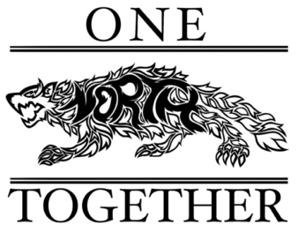

Fall Festival Meeting
September 27, 2023

Attendees: Dr. Turner, Stacey Bertotti, Jen Patton, Marney Lumpkin, Stacey Morris, Mariana Gran, Holly Reyes, Alethia Byrd

Call to Order: 5:12pm

Marketing
- Post on the marquee on the outside
- Post on Stafford talk, Stafford moms, etc.…
- Possibly make an announcement on the radio
- Michelle Treakle will be sending out an email announcement with the sign up genius
- Start on vendor announcements – 2 parking spots per vendor

Food
- Liza Z. has 2 food trucks committed so far and will reach out to more
- NSHS clubs have committed to supplying popcorn, cider and caramel apples

Activities
- Stacey Bertotti is waiting for an updated quote for the inflatables
- 2 people have shown interest to be vendors so far
- Holly Reyes will reach out to local farms regarding cost for 200 pumpkins
- Ms. Lynch has committed a few students to offer face painting
- Mariana Gran will reach out to Sarah McGuire regarding tanks and Marine volunteers
- Stacey Bertotti is making a quilt to raffle off
- Stacey Bertotti will send solicitation letter to Mariana Gran to gather items for auction
- Will have music and a possible cake walk as well
- Marney Lumpkin will reach out to the sheriff’s office and inquire about fingerprinting for kids

Volunteers
- Learn & Serve and National Honor Society have committed to helping
- AFJROTC will providing clean up after the event and the colors at the beginning
- Several volunteers have signed up but more are needed

Adjourned: 5:48pm

