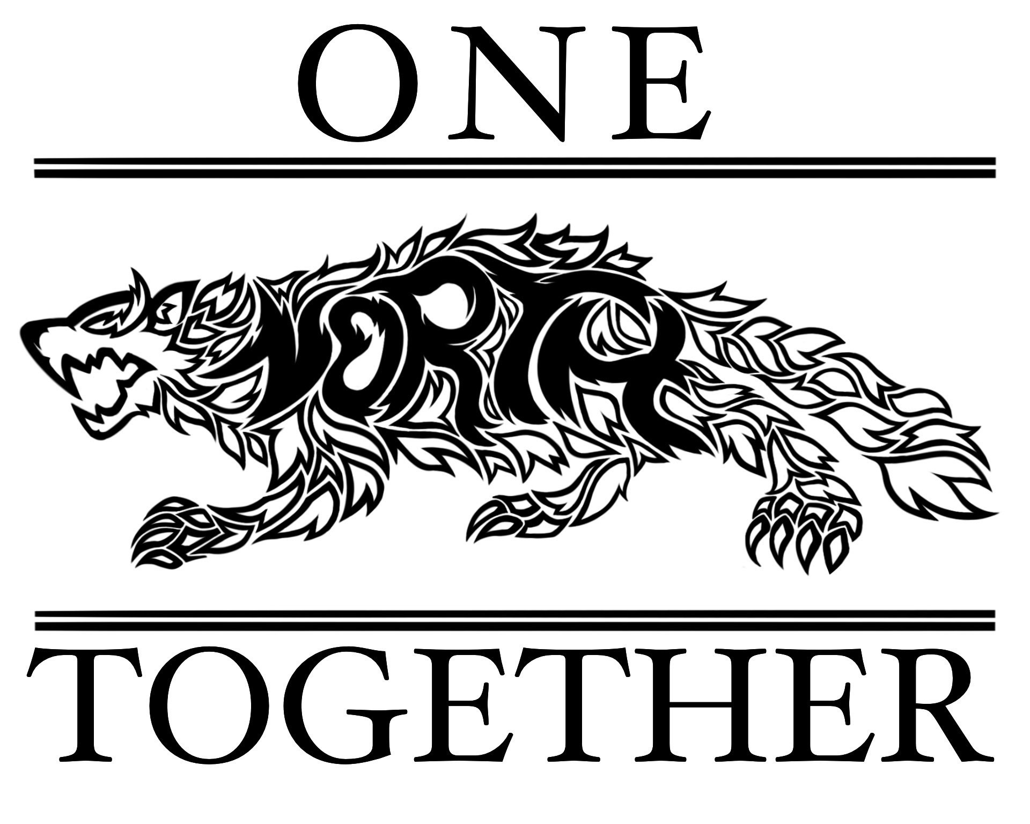

NSHS PTSO Board Meeting Agenda
January 10, 2024

Attendees: Stacey Bertotti, Jen Patton, Jess Navarro, Marney Lumpkin, Monica Santiago and Alethia Byrd

I. Call to order – 4:01pm

II. Approve minutes from December 11, 2023 – All approved

III. Treasurer Report
- Current balance in account as of COB 1/09 = ___$27,211.59__
- Detailed reports in the drive and reviewed during the meeting
- Budget
- Upcoming Expenses:
  - Prizes and items for raffle basket for Bingo
  - Spring Teacher Grants
IV. President Notes
- Teacher Grant for Ms. Collette – to approve
- Stacey Bertotti will handle the embroidery portion
- May ask for funds towards thread
- Waiting to verify with Amanda Collette regarding what lab coats to order
- Bingo application and prize gathering update –
- Will be held on February 3rd
- Still waiting for approval on permit
- Communications need to go out once it is approved
- Update website and social media
- Share with other schools and on Peachjar
- Will need to ask clubs/groups for themed baskets
- Serve hot dogs in crockpots and sell snacks from muffin cart
- Stacey Bertotti will share the letters to gain donations
- Rising Freshman/New Student Night January 11
- Need volunteers
  - Stacey Bertotti will attend
  - Send a text to muffin cart ladies to see who can volunteer
  - Jen Patton and Jess Navarro should be able to assist
  - Setup at 4pm
  - Will bring applications and thermometer
- Sign up genius for muffin cart for the next few weeks

V. Executive President

VII. Membership Update

VIII. Vice President
- Where are we at with the closet for clothing and hygiene items?
- We need to contact Suzie Durham

IX. Staffulty Representatives/ Lindsey had the baby yesterday!!!!

X. New Business –
- Draft a statement to send out to membership and principal newsletter regarding upcoming board nominations

XI. Meeting Adjourns – 4:22pm
- Jen Patton made a motion, Marney Lumpkin seconded and all approved

Next meeting: February 7, 2024

