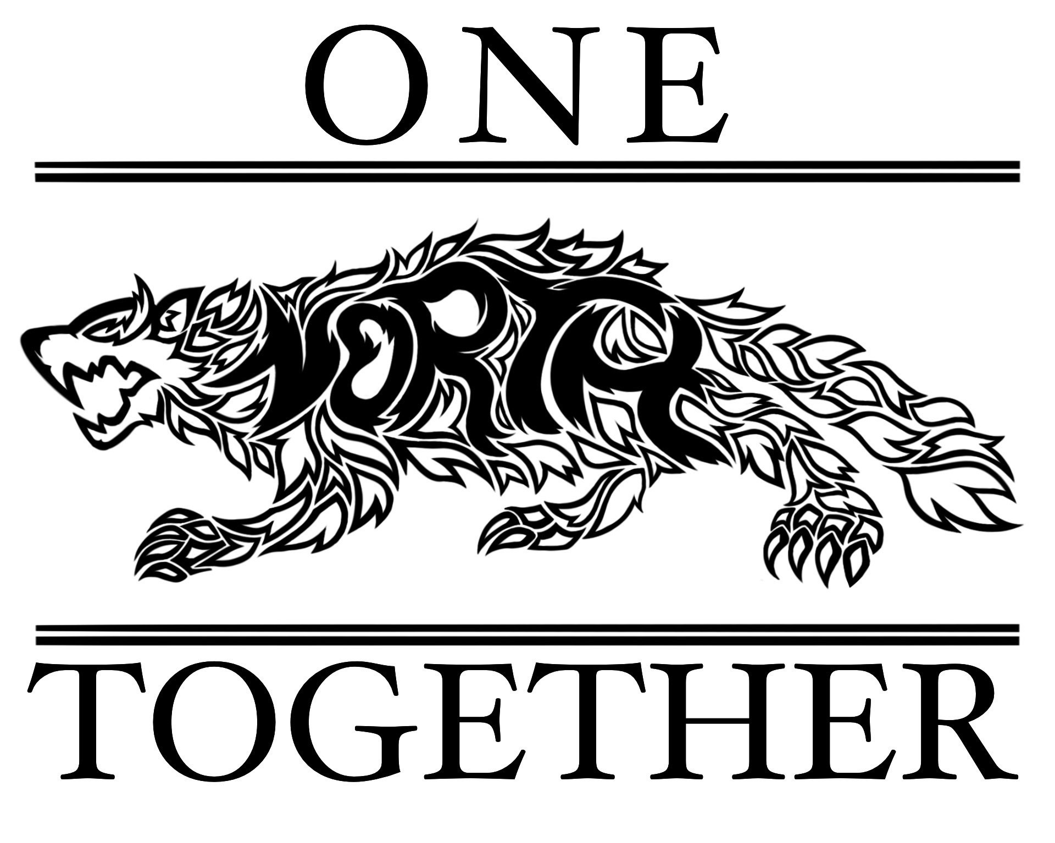

NSHS PTSO Board Meeting Notes
December 13, 2023

Attendees: Stacey Bertotti, Jen Patton, Jessica Navarro, Marney Lumpkin, Dr. Turner, Alethia Byrd, Monica Santiago, Lindsay Long

I. Call to order: 4:38pm

II. Approve minutes from November 7, 2023
- Jen Patton motioned, Jessica Navarro seconded and all approved

III. Treasurer Report
- Detailed Report is in the drive
- Current balance in account as of COB 12/13/23 = ___$27,203.84__
- Budget reviewed
- Upcoming Expenses:
    - Prizes for Teacher Holiday Breakfast on 12/20
    - Prizes and items for raffle basket for Bingo
    - Fund additional grant if approved
    - Will have to replenish MC in early January since we have sold down the stock

IV. President Notes
- Teacher Grant for Ms. Collette – to approve
- PTSO will give $600 and Dr. Turner will look for an additional $300
- Table approval pending research for less expensive lab coats
- Vote will be via email
- Bingo application and prize gathering update
  - Stacey Bertotti will send in application in the next few weeks via email
  - Need to start getting raffle baskets together
  - Purchase prizes
  - Send out message to staff for department baskets
  - Update bingo raffle flyer
  - Share on website, social media and peachjar
  - Will have additional bingo related meetings
- Staffulty Breakfast and raffle
  - Volunteer help needed to manage the raffle portion and pass out prizes
  - Breakfast at 6:15am/6:30am
  - Will need to pick up a few more gift cards and gifts

V. Executive President
- Solid year so far
- Really appreciate the funding and support

VII. Membership Update
- 57 family, 64 staffulty, 1 student

VIII. Vice President
- Nothing to report at this time

IX. Staffulty Representatives
- Thank you for the grants

X. New Business

XI. Meeting Adjourns
- Jen Patton motioned, Jessica Navarro seconded and all approved

Next meeting: January 10, 2024

