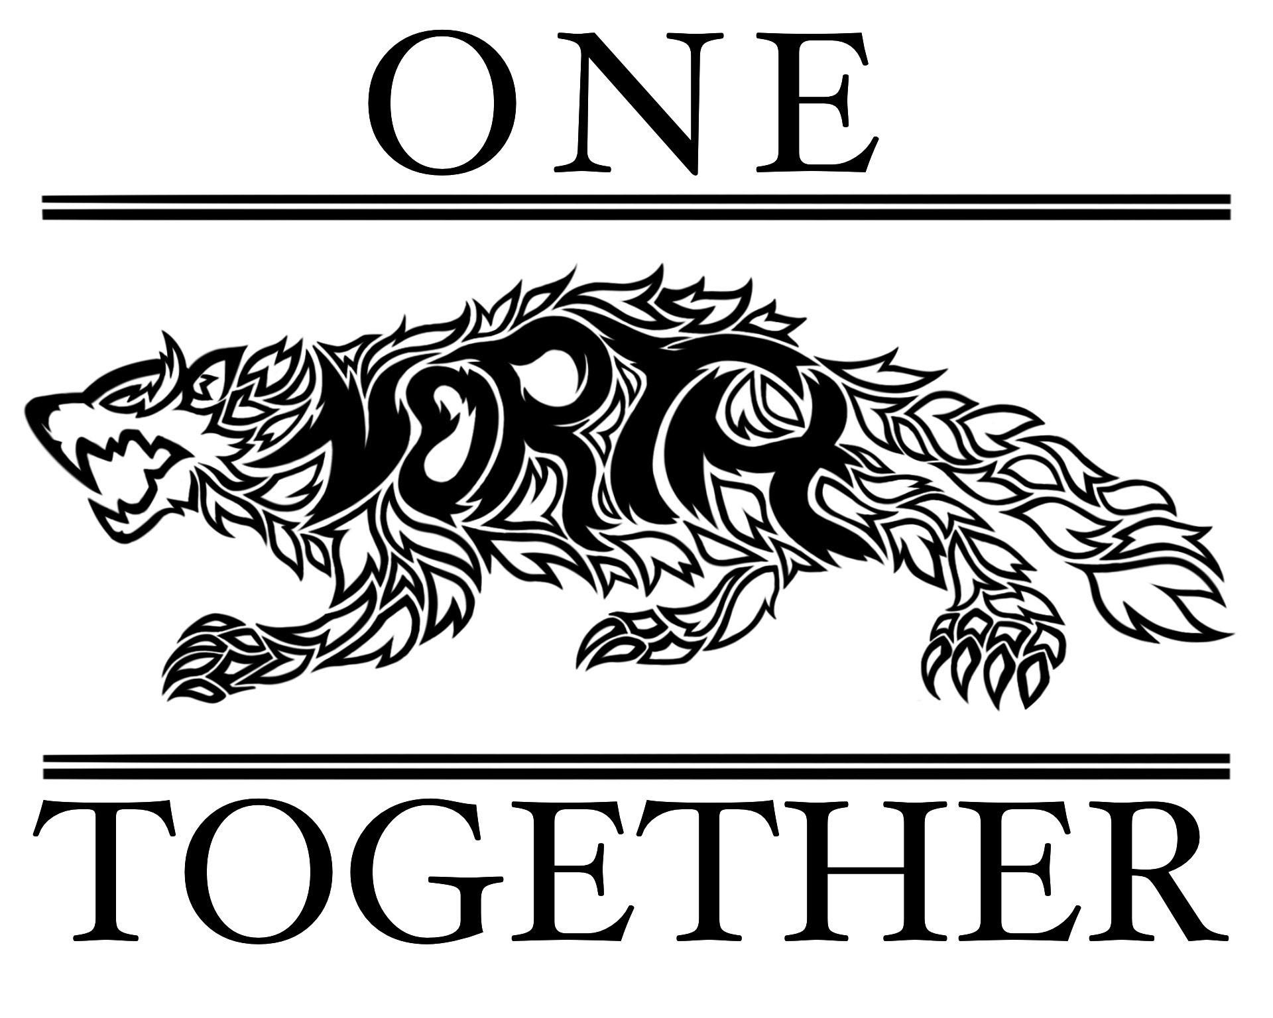

NSHS PTSO Board Meeting
October 4, 2023

Attendees: Dr. Mayonne, Stacey Bertotti, Jen Patton, Jessica Navarro, Holly Reyes, Monica Santiago, Sarah Maguire, Stacy Morris, Jana Ayres, Lindsey Long

I. Call to order – 5:03pm

II. Approve minutes from July 5, 2023 – all approved
III. Treasurer Report
- Fiscal report for September
  - $22,703.36 1 as of 4pm 10/03/23
  - 3 checks outstanding -
    - One scholarship check from May 2023; Dr. Mayonne provided the parents contact information, Jen will call.
    - Two checks to NSHS - Renaissance & Wrestling - disbursements from their use of our square account.
  - Upcoming Expenses:
    - Fall Teacher Grants - approved budget of $2,500
    - Fall Festival - current approved budget is $1,500. Will need to adjust with a vote if more is needed based on estimates.
    - Grocery Gift Cards requested by school social worker - funds will come from approved “Other Student Support”.

IV. President Notes
- Reviewed the resignation from Ms. Marianna Gran (sitting VP)
  - Resignation acknowledged by the Executive Board.
  - Motion to recognize Ms. Jessica Navarro as interim VP was made by Jen, Lindsey seconded; all approved.
  - We will advertise for 30 days for a new VP (Sarah will post to social media); vote in the new VP at the next meeting.
    - Move the next meeting to November 8 at 5pm to allow for closure of the books and a full 30 day advertisement.
- Teacher Grants
  - Several grant requests were received, but it was realized that an email never went to staff informing them of grant open season
  - Stacey will send a grant form to Dr. Turner to send to staff
  - Given a short turnaround time, the board can meet separately to vote on grants or vote via email.
- Bingo License
  - Stacey spoke to the man working on our old 17 page application. He had a question for us.
    - Stacey sent an email canceling our application and will submit the new 1 page application
    - License is only good for one day.
      - Dr. Mayonne looked at February’s calendar - potentially the 3rd or 10th may work.
- Breast Cancer Awareness T-shirts
  - Orange Fever is selling shorts for $10
  - We are interested in buying shirts for board members and MC volunteers to wear during October
    - Stacey sent a message asking if shirts were available now or did they need to be ordered.
- Fall Festival
  - Inflatable
    - Quote received for obstacle course, bounce house, and dunk tank - $1390 (includes generators).
    - Two vendors have signed up
    - Leadership and Learn & Serve students will help with the Fall Festival
    - Larissa Lynch will provide paint for face painting and may also have a couple of students interested in doing the face painting.
    - Renaissance updates from Lisa Z
      - They will sell caramel apples, cider, and popcorn
      - She was in touch with a woman about providing a petting zoo - outcome pending
    - Still need more volunteers
    - Need to schedule a Fall Festival meeting to work out details of prices of tickets, how many tickets per activity, signs (advertising and for areas at the festival), concession food and pricing, etc. Would like to accommodate Lisa’s schedule so she can be present.
  - Pumpkins (update from Holly)
    - Spoke with many farms and two are able to help
      - Meadows Farms - 250 pumpkins for $457.50. They will deliver Friday, 10/27, up to 5pm
        - The consensus in the room was to use Meadows farms
        - The question was raised of where would put them Friday night.
      - Sneads Farms - $2/pumpkin flat rate. We would need to go to the field and pick the pumpkins ourselves and bring them to the school.
    - Discussion about “pumpkin patch” during the Festival or have them in a bin for families to select one before leaving.
      - No decorating of pumpkins as there is no where to was up or wash supplies
      - There will be no charge for pumpkins
      - A suggestion was made to give an orange ticket to those buying tickets to use to claim their pumpkin
    - Hay Rides
      - Mr. Rossi is unavailable to provide hay rides on the day of the Fall Festival
    - Dunk Tank Discussion
      - Suggest cost 3 balls/$5 or 4 balls/$5 with a NSHS student ID.
        - Not sure how this will translate into tickets yet since tickets will be used instead of cash
        - Dunk tank will need to be on a flat surface, suggested the first couple of parking spaces before the stairs in the front parking lot.

V. Executive President
- Student Incentives
  - Dr. Turner requested $500 to use for student incentives to improve the chronic absenteeism at North
    - He will gather a focus group to determine appropriate incentives
    - Motion to approve made by Stacy Morris, Jen seconded, all approved

VII. Membership Update
- Currently have 50 families and 47 staffulty members

VIII. Vice President
- Jessica gave us an introduction of herself since many in the room had never met her.

IX. Staffulty Representatives
- Nothing at this time

X. New Business
- Discussed starting a cabinet or cart with personal care products for students who may not have resources at home to get these things.
  - Reach out to the school social worker to discuss. We need space and someone who would be available to let students in to get what they need.
- Discussed partnering with Rodney Thompson Middle School, Leadership, and Learn & Serve to sponsor families in need this holiday season.
  - Stacey offered to set up a meeting with partners to plan.
- Breakfast for Teachers on 10/9/23
  - Sandra inquired if we could provide breakfast for 135 on Monday, 10/9
  - Jen made a motion to approve $300 for breakfast, Dr. Mayronne seconded, all approved.

XI. Meeting Adjourns - 6:28pm

