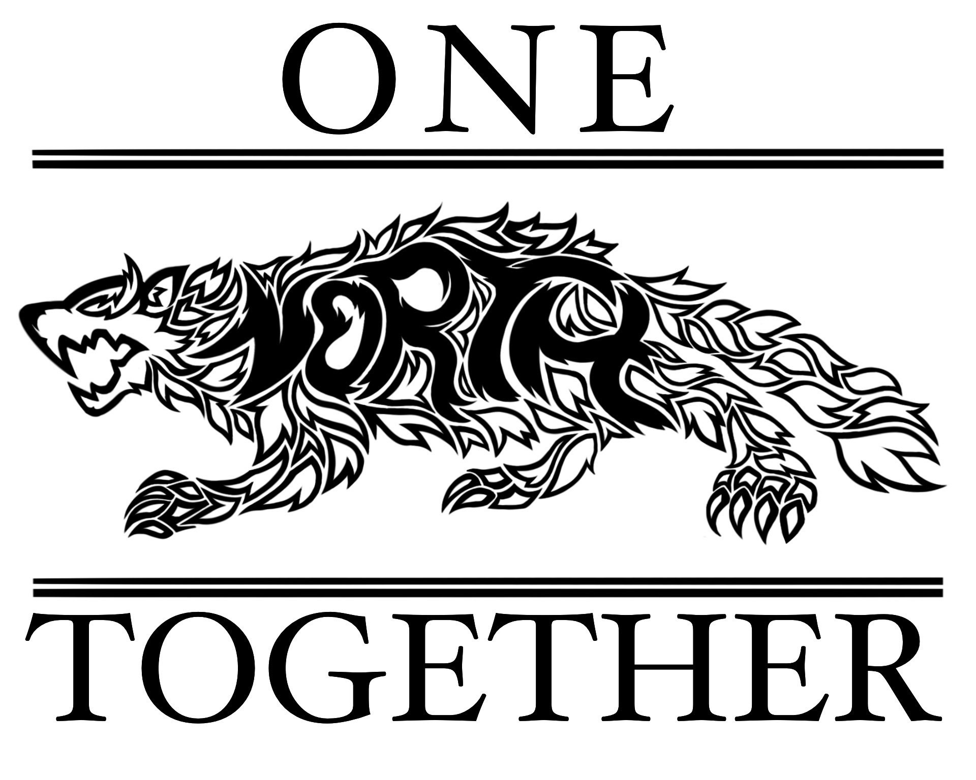

Fall Festival Meeting
September 14, 2023

Attendees: Dr. Turner, Stacey Bertotti, Jen Patton, Marney Lumpkin, Jana Ayers, Holly Reyes, Mariana Gran, Monica Santiago, Alethia Byrd and Stacey Morris

Time and Date
- October 28th
- 12-5pm

Food
- Renaissance has offered to do popcorn and hot cider
- Bring in several food trucks – Mariana Gran will be coordinating this
- PTSO will have a cotton candy machine and snow cone machine

Activities
- Stacey Bertotti will talk to Mr. Rossi about possible hay rides
- Possibly have a cake auction
- Dunk Tank
- 50/50 raffle
- Small pumpkins- possibly from Aldi
- Stacey Bertotti will make a quilt to raffle off
- Moon bounce and obstacle course
- Fingerprinting for kids
- Photobooth
- Jen Patton will inquire about HRT
- Ask Mrs. Lynch about students volunteering to do face painting
- Sarah McGuire will ask about a tank and dog handlers

Financial
- $40 for each table for vendors and $10 if they need an extra table
- Dunk Tank - $5 for 3 chances
- Photobooth - $5 per photo

Logistics
- Possibly have food trucks be in the “U” in the front
- Festival will take place on the fields in front of the school
- Parking in student parking lot and bus ramp area
- Doors in the front of the school will be open for bathroom use
- Notify police and fire department for safety and security purposes
- Vendors will need to bring generators if they need it
- Sign up genius will be sent out for vendors to register
- Sign up genius will be sent out for volunteers
- Use big speakers for music
- Ask JROTC to help with colors and cleanup
- Sarah McGuire will assist with advertising for vendors
- PTSO will have a table for spirit wear, memberships and 50/50

Additional Items
- Reapply for 2024 nonexempt status
- Stacey Bertotti will follow up with Bingo application
- Other fundraising ideas include shoe donation and garage sale

