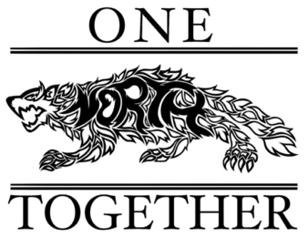

Fall Festival Meeting
October 11, 2023

Attendees: Dr. Turner, Stacey Bertotti, Jessica Navarro, Jen Patton, Marney Lumpkin, Stacey Morris, Jana Ayers and Holly Reyes

Financial
- Paid deposit for inflatables and dunk tank
- Company would like a check at the end of the event
- We need to make at least $2000 to break even

Food
- Lisa Z. has secured 5 or 6 food trucks (Renaissance will keep the funds and we will need to reimburse any purchases made on square)

Activities
- Quantico Marine Corps base is supplying K9’s and a tank
- Jen Patton is completing the Sherriff’s event request form (will be focused on holiday safety tips)
- Marney Lumpkin completed the form to request fingerprinting for children
- Pumpkins are $1.83 each and will be delivered on Friday evening
- Face painting and pumpkins are free
- Square readers will need to be at the PTSO table, ticket booth and concessions
- Stacey Bertotti has made a quilt to raffle off
- Bake sale – ask for donations from members
- Lisa Z. is looking into a petting zoo being there
- Stacey Morris volunteered her husband to make a wooden flag to raffle off
- 50/50
- Visa gift cards for PTSO members – use a randomizer to pick the names

Volunteers
- Stacey Bertotti will talk to Coach Lloyd about providing school security
- Still in need of several volunteers
- JROTC will be providing the colors and cleanup
- NSHS Honor Society will be providing volunteers
- Dr. Turner and Dr. Mayronne have offered to be in the dunk tank

Tickets
- All tickets are $1 each
- 2 tickets for bounce house
- 3 tickets for obstacle course
- 5 tickets for 3 balls for dunk tank

Vendors
- Currently have 3 vendors signed up – have space for 40 total

Marketing
- Stacey Bertotti will send the links to Michelle Trenkle for sharing with central office
- Signs need to be made for the ticket booth
- Encourage sharing on social media
- Dr. Turner will send out a message to the teachers regarding volunteering
- Dr. Turner will do a robo call for volunteers on the 16th and a robo call on the 23rd regarding the event – Stacey Bertotti will send Dr. Turner a write up
- Dr. Turner will include information in an upcoming newsletter to the school community

